|  |  |  |  |
| --- | --- | --- | --- |
| **Lyng Primary School Knowledge Organiser** | | | |
| **Topic:** | **Ancient Greece – Why were Ancient Greek trade links so effective?** | Year 5  *Civilisation, Communication and Creation* | Spring 2 |

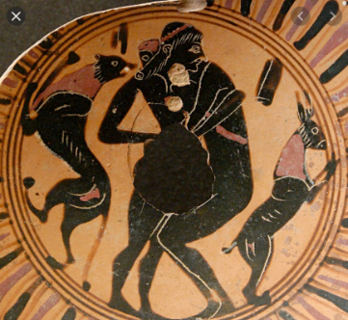

**Background information for parents and teachers.**

**Ancient Greek civilization**, the period following [Mycenaean](https://www.britannica.com/place/Mycenae) civilization, which ended about 1200 BCE, to the death of [Alexander the Great](https://www.britannica.com/biography/Alexander-the-Great), in 323 BCE. It was a period of political, philosophical, artistic, and scientific achievements that formed a [legacy](https://www.merriam-webster.com/dictionary/legacy) with unparalleled influence on Western civilization.

|  |  |
| --- | --- |
| **What Step On and Goldilocks words will I use?** | |
| **Spelling** | **Definition** |
| Mountainous | Lots of mountains |
| Climate | Typical weather of that place |
| Territory | Land which is controlled by different rulers |
| Peninsula | Narrow land which sticks out from a larger piece of land which is then almost completely surrounded by water. |
| Sea-faring | Regularly travelling by sea |
| Mediterranean | Southern part of Europe. Also a sea between South Europe and North Africa. |
| Aegean | Region comprising of the Aegean Sea and islands |
| Harbour | A sheltered port so that boats can be left safely |
| Port | A harbour where boats and ships can be loaded and unloaded of goods and passengers |
| Migration | Movements from one place to another to settle |
| Coastline | Area of land by the sea |
|  | |

|  |
| --- |
| **Geographical study** |
| **Navigating the world – How did the Greeks travel to trade?**   * Understand some of the reasons for geographical similarities and differences between countries. * Compare the physical geography of Greece to the UK. * Understand and compare imported and exported items from each location. |

**Fieldwork Opportunities**

•Use aerial photographs to compare West Bromwich in the UK and Greece in Europe. What is the same? What is different?

**Significant places**

Athens  
Aegean Islands

**Our Storytelling Approach to enhance engagement**

|  |  |  |
| --- | --- | --- |
| **People:**  Theseus | **Place:**  Greece | **Problem:**  Mythical beast escape |

**Key facts and locations**

**Map to be studied**

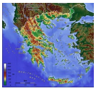

Greece is located in Europe, bordering the Ionian Sea and the Mediterranean Sea. It is a peninsular country, with approximately 3,000 islands. Greece is in Southern Europe. It is bordered by Albania, the Republic of Macedonia, and Bulgaria in north and in east by Turkey.

Greece has a landscape of forests, rivers, mountain ranges and beaches.

The climate can range from hot and dry to cold mountain forests, depending on the region and time of year.

The northern part of Greece can be very cold during the winter and snow is not uncommon.

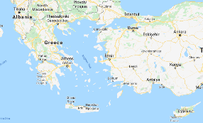

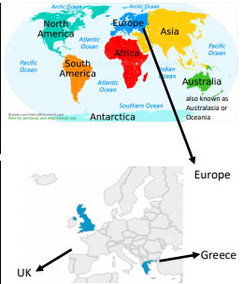

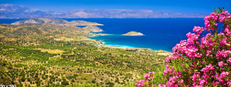

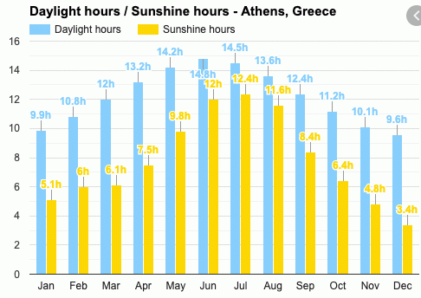

**Agreed Outcome**

Tourism brochure about visiting Greece

|  |  |  |
| --- | --- | --- |
| **People:**  Theseus | **Place:**  Greece | **Problem:**  Mythical beast escape |

* How did the Geography of Greece impact the lives of the Greeks?
* What is the impact of the geography of the land on the lives of the Ancient Greeks?
* Why are locations around the world changing?
* What impact did the Greek city states have on Greece?

**Key Questions – Sequence of Learning**

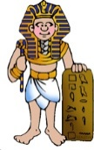

|  |  |  |
| --- | --- | --- |
| 7. Name 4 Ancient Greek states. | **S** | **E** |
| 1.  2.  3.  4. |  |  |
| 8. Which state was a democracy? | **S** | **E** |
|  |  |  |
| 9. Describe the landscape of Greece | **S** | **E** |
|  |  |  |
| 10. Ancient Greece was mountainous. | **S** | **E** |
| True |  |  |
| False |  |  |

**Our Ancient Greek Quick Quiz**

|  |  |  |
| --- | --- | --- |
| 1. Which continent is Ancient Greece located? | **S** | **E** |
| Africa |  |  |
| Europe |  |  |
| Asia |  |  |
| 2. Ancient Greek climate was….. | **S** | **E** |
| Cold and windy |  |  |
| Warm and dry |  |  |
| Hot and dry |  |  |
| Wet and windy |  |  |
| 3. The first island Ancient Greeks settled on was called | **S** | **E** |
| Crete |  |  |
| Santorini |  |  |
| Mykonos |  |  |

|  |  |  |
| --- | --- | --- |
| 4. Ancient Greek theatres were built on……. | **S** | **E** |
| Mountains |  |  |
| Sea |  |  |
| Hillsides |  |  |
| 5. Which sea surrounds Greece | **S** | **E** |
| Atlantic sea |  |  |
| Mediterranean sea |  |  |
| North sea |  |  |
| 6. Why did the Ancient Greeks sail the seas? | **S** | **E** |
|  |  |  |